**MAHENDRA INSTITUTE OF ENGINEERING AND TECHONOLGY**

***SMART WATER MANAGEMENT***

**PROBLEM DEFINING AND DECISIONTHINKING**

**TEAM MEMBERS:**

**T.SATHISHKUMAR**

**V.SARAVANAN**

**P.PONVIJAY**

**E.CHANDRU**

**S.HARIHARAN**

**CORDINATOR:**

**Mrs. ARUNAA**

**PLANNING :**

This is used for water level detection and automatic ON/OFF the motor for water tanks. By using IOT the data is upload on Ada fruit platform. Laser sensor is placed above the tank toknowthe level of the water in the tank. When water falls below the threshold value the motor is automatically ON.

**INSTALLATION :**

The Arduino UNO has super convenient power management and built-in voltage regulation.The Arduino can be directly powered through USBor external power supply. The external power supply can be given by • Connecting power source(7-12v DC) to DC power jack • Connecting a battery lead to Vin and Gnd. 5V and 3.3Vare used to provide power to sensors and modules when connecting it to. The temperature sensor LM35IC has been used for sensing the temperature. It is an integrated circuit sensor that can be used to measure temperature with an electrical output proportional to the temperature. The temperature can be measured more accurately with it than using a thermistor. The sensor circuit ryis sealed and not subject to oxidation, etc. It is a three terminal sensor used to measure the surrounding temperature ranging from -55 degree centigrade to 150 degree centigrade.

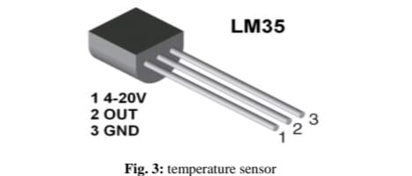

**CONTROLLING :**

Temperature sensor Water flow sensor are installed at the water sources or pipes to measure the rate of flow of water and calculate the amount of water flowed through the pipe. Rate of flow of water is measured as liter per hour or cubic meters. Water flow sensor consists of plastic valve from which water can pass. A water rotor along with a hall effect sensor is present and measure the water flow. The main working principle behind the working of this sensor is the hall effect. According to this principle , in this sensor , a voltage difference is induced in the conductor due to rotation of the rotor. This induced voltage difference is transverse to the electric current.

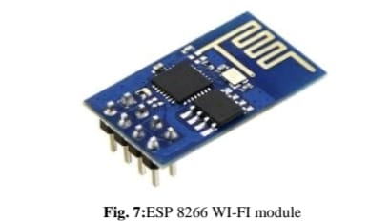

water flow sensor The HC-SR04 ultrasonic module is a module that can provide noncontact measurement within the range of 2cm to 400cm with an ranging accuracy that can reach 3mm. It works on the principle of echolocation. The ultrasonic sensor as a trigger and an echo pins. The Arduino provides a high signal of 10microseconds to this pin. The sensor is trigged, it send out a 840khz to the surface of the water. On getting to the surface of the water, the wave is echoed back to the sensor and the Arduino reads the echo pin to determinr the time between the triggring and receciving of the echo

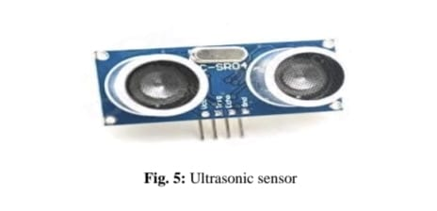

The Arduino Uno is used as microcontroller in this structure , it has 14 propelled data/yield pins of which the user are using 6 pins for interfacing sensors-waterflow , Ultrasonic and temperature. Interfacing the wi-fi module ESP8266 with Arduino for giving an electronic system. Arduino is a microcontroller board subject to the Atmega328p. A 1 MHz quartz valuable stone, a USB affiliation, a power jack, a reset

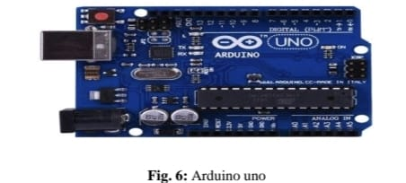

The ESP8266 can do either offloading wi-fi frameworks organization limits from another application processor or encouraging an application. The ESP8266 wi-fi module is a free SOC with facilitated TCP/IP show stack that can giveany microcontroller to access to the wi-fi range. This module has an earth shattering enough prepared getting ready and limit capacity that empowers it to be composed with the sensors.



ESP 8266 WI-FI module The SIM900 is a quad-band GSM/GPRS solution is a SMT module which can be embedded in the customer applications. Featuring an industry standard , interface the SIM900 delivers GSM/GPRS 850/900/1800/1900MHz performance for the voice, sms , data with small power consumption. A 16*2 LCD has two registers namely, command and the data. The register select is used to switch from one register to other. RS=0 for command register and RS=1 for data register

**CLOSING :**

The water sector has been grappling with creating an efficient and long-lasting water system. It is included in the IoT-SWM. People intend to broadcast more data to the cloud and analyze it further to construct some algorithm to determine the tank’s lifespan and the proper aspects of leaking. Procedures and actions are determined depending on the threshold, capital cost, and the accessibility of equipment and materials. Even though statistically minimal water savings can be achieved using in-line flow restrictors, they can be much more cost-effective than water-efficient taps in certain situations. If they have been installed as part of normal maintenance visits, the expenses would be lower. They are a low-cost alternative to outdated toilets and are unlikely to save a lot of water. When it the time comes to renovate restrooms, installing water-saving toilets should be considered. To better understand the workings of a crisis-stricken metropolis, this urban crisis feedback analysis tool should be used. With this approach, municipal stakeholders affected by a natural disaster can better plan for a future occurrence of a comparable hazard. We have compiled a list of the most important features of advanced water management systems. There are still barriers to real-time measurement that need minimal energy use. With this in mind, we propose as future work an IoT-based design for a smart water management system that takes into account all of these crucial characteristics and makes use of IoT-based predictions to boost the smart management system’s efficacy. As a bonus, future research can use the Internet of Things coverage factor while calculating measurement uncertainty. The authors offer recommendations for the next steps and research groups to join to improve IoT security, lessen the impact of organisms, implement AI/ML approaches, and reduce the entire system’s cost. The numerical outcome of the proposed method increases the stormwater quality (98.7%), the efficiency ratio (95.1%), water demand ratio (93.6%), the leakage detection ratio (97.5%), and non-revenue water ratio (98.4%).

**CODING :**

**# Import necessary libraries**

**import time**

**import random**

**# Simulate water quality and flow sensors**

**def read_sensor_data():**

**water_quality = random.uniform(0, 14) # pH level**

**flow_rate = random.uniform(0, 10) # Liters per minute**

**return water_quality, flow_rate**

**# Connect to IoT platform or cloud service**

**def connect_to_cloud():**

**# Implement code to connect to your cloud platform (e.g., MQTT, HTTP, or other protocols)**

**# You would typically need authentication and connection settings here**

**print("Connected to IoT Cloud")**

**# Main loop for data collection and transmission**

**while True:**

**water_quality, flow_rate = read_sensor_data()**

**# Send sensor data to the cloud**

**data_to_send = {**

**"water_quality": water_quality,**

**"flow_rate": flow_rate**

**}**

**# Implement code to send data to the cloud platform**

**# You can also add code to monitor for anomalies and take actions as needed**

**print(f"Water Quality: {water_quality}, Flow Rate: {flow_rate}")**

**# Sleep for a specified time (e.g., every 15 minutes)**

**time.sleep(900) # 15 minutes = 900 seconds**

**EXECUTION:**

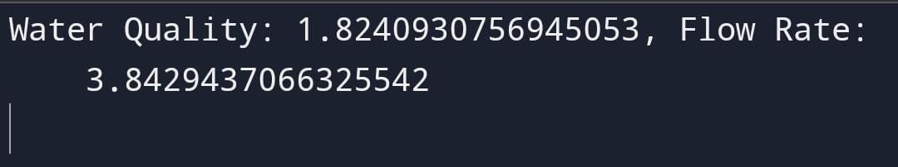

**RESULT :**

Thus the smart water management using iot project is running and execution is successfully…